**Echinoderm Fact Sheet**

| **Shared Features** | **Variations on the Shared Features** |
| --- | --- |
| * Slow moving * Lack body segments * Radial symmetry * Endoskeleton covered with a rough, spiny skin * Water vascular system: a network of water-filled canals used to move, feed and “breathe” * Tube feet are part of the water vascular system that project outward from endoskeleton * Some are able to regenerate lost arms * Larval stage has bilateral symmetry * Development is very similar to chordate development | 1. Sea Stars (Asteroidea): predators of mollusks, crabs, other echinoderms; tube feet to walk or stick; 2. Brittle Stars (Ophiuroidea): long slender and flexible arms; catch food with arms, not for moving; 3. Sea Urchins Echinoidea): no arms; spines protect body; tube feet to move; scrape rocks for food 4. Sea Cucumbers (Holothuroidea): soft, flexible body beneath leathery skin; mouth with tentacles to filter feed |

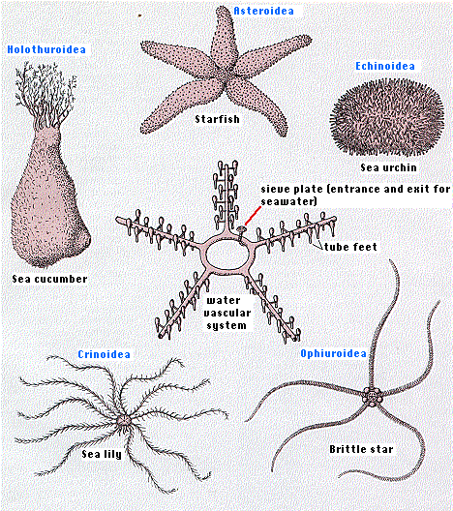

**Embryo of a Sea Star**

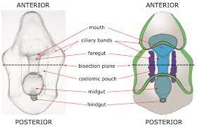

**Embryonic Development**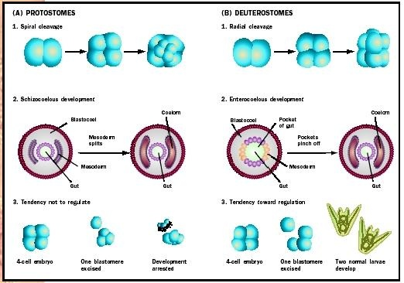

**Protostome Development- all invertebrates except Echinoderms**

**Deuterostome Development- Echinoderms and Chordates**

**Comparing Embryonic Development**

| Sea Star (Echinoderm) |  |
| --- | --- |
| Cephalochordates (lancelets) & Urochordata (sea squirts or tunicates) |  |
| **Vertebrate** Chordates |  |

**Cephalochordata Fact Sheet**

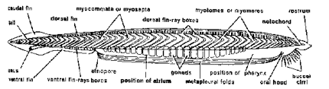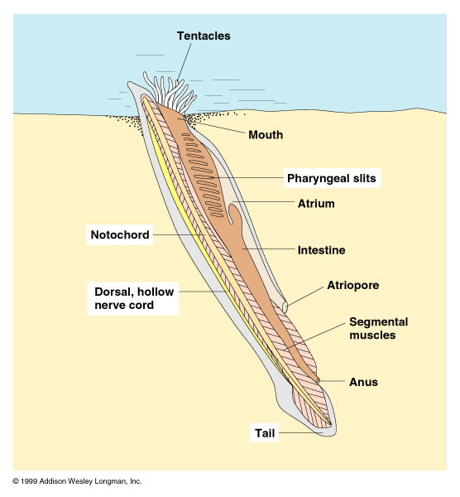

* Commonly called lancelets or amphioxus
* Eel-like in appearance
* Have all the Chordate features:
  + Dorsal hollow nerve cord
  + Pharyngeal gill slits
  + Segmented muscles
  + Post-anal tail
  + Notochord
* Small, simple brain
* No backbone
* Simple sense organs
* Filter feed
* Simple digestive system
* Separate sexes

**Urochordata Fact Sheet**

* Commonly called tunicates or sea squirts
* Adult and larval forms are quite different

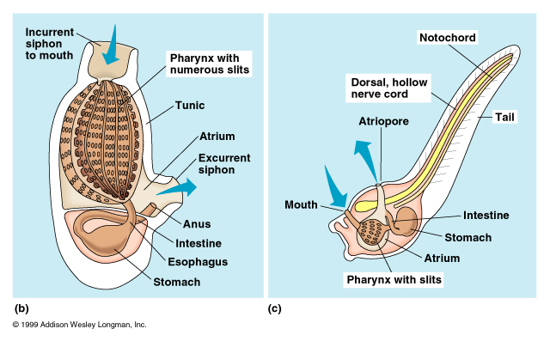

| **Adult** | **Larva** |
| --- | --- |
| * Simply a sack with two siphons * Filter water in one and out the other to capture food * Attached to bottom or other objects * Salps are free-swimming * No tail * Simple or no nervous system * Hermaphroditic * Lose chordate features | * Free-swimming * Have all the Chordate features:   + Dorsal hollow nerve cord   + Pharyngeal gill slits   + Segmented muscles   + Post-anal tail   + Notochord * Loses tail when it attaches to a surface and grows into adult form |

**Vertebrate Chordates Fact Sheet**

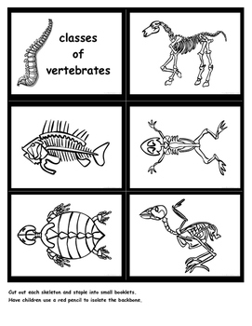

* At some point during development possess:
  + All the Chordate features:
    - Dorsal hollow nerve cord
    - Pharyngeal gill slits
    - Segmented muscles
    - Post-anal tail
    - Notochord
* Lose many of the chordate features during development
* Body regions-head, chest, abdomen, appendages
* Endoskeleton
  + Skull to protect brain
  + Vertebral column of vertebrae to protect dorsal nerve cord; no more notochord
  + Ribs to protect heart
  + Two pairs of appendages
  + Most have a jaw
  + Most have tails
* Heart and closed circulatory system
* Complex muscular system
* Complete digestive tract from mouth to anus
* Include fish, amphibians, reptiles, birds, and mammals